**SPRINT REVIEW MEETING**

Goal : **see what was done and share the knowledge**

**Sprint 1:**

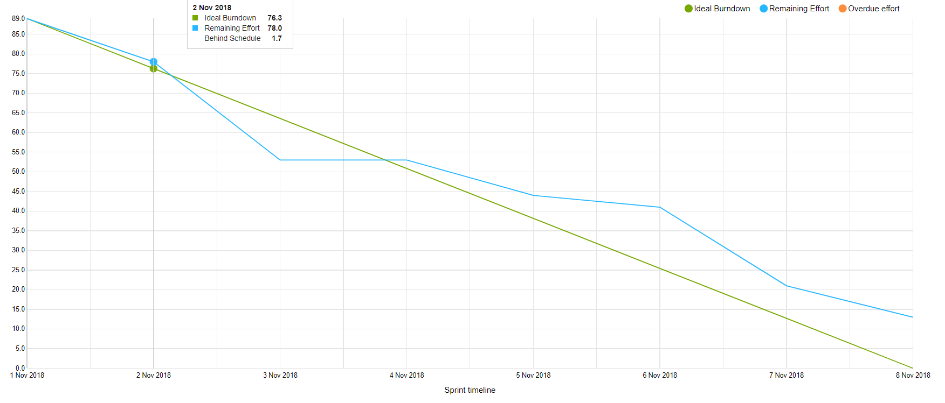

**What is missing:**

* GUI showing result on website is in the progress and moved to the next sprint
* Diagrams for database moved to the next sprint

**What is done:**

* Class diagrams : Model, Bookstore/Library, book service
* Activity diagram : search for a book
* Database structure for books
* Implement model
* Communication protocol : search and advanced search
* Library expose REST for searching the book
* Book service redirecting and gathering book queries
* Search engine on database server
* Database server
* Library/Bookstore connect to database
* GUI : search page (main page)

**Sprint 2:**

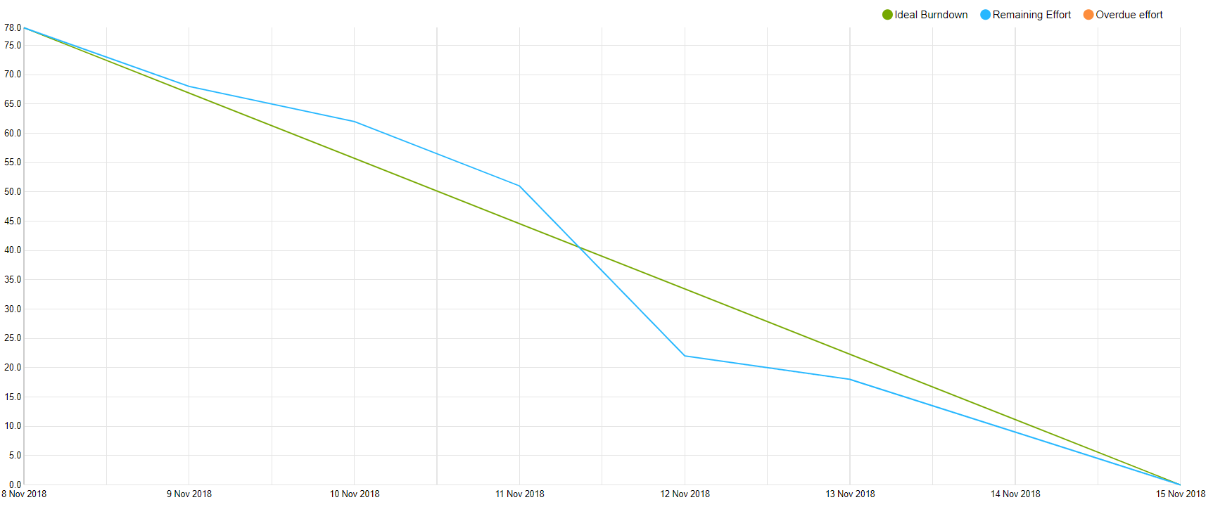

**What is missing:**

* Crud Tests for bookstore moved to next sprint
* GUI Admin page in progress
* GUI Advance search in progress
* GUI Book details page in progress

**What is done:**

* Class diagram : update
* Database diagram
* Use case description for those stories
* Find out if ISBN is good for id
* Library/Bookstore : CRUD
* Book service : book details
* Database : availability
* Database : update connection
* Configure TRAVIS for C#
* Set up deploy

**Sprint 3:**

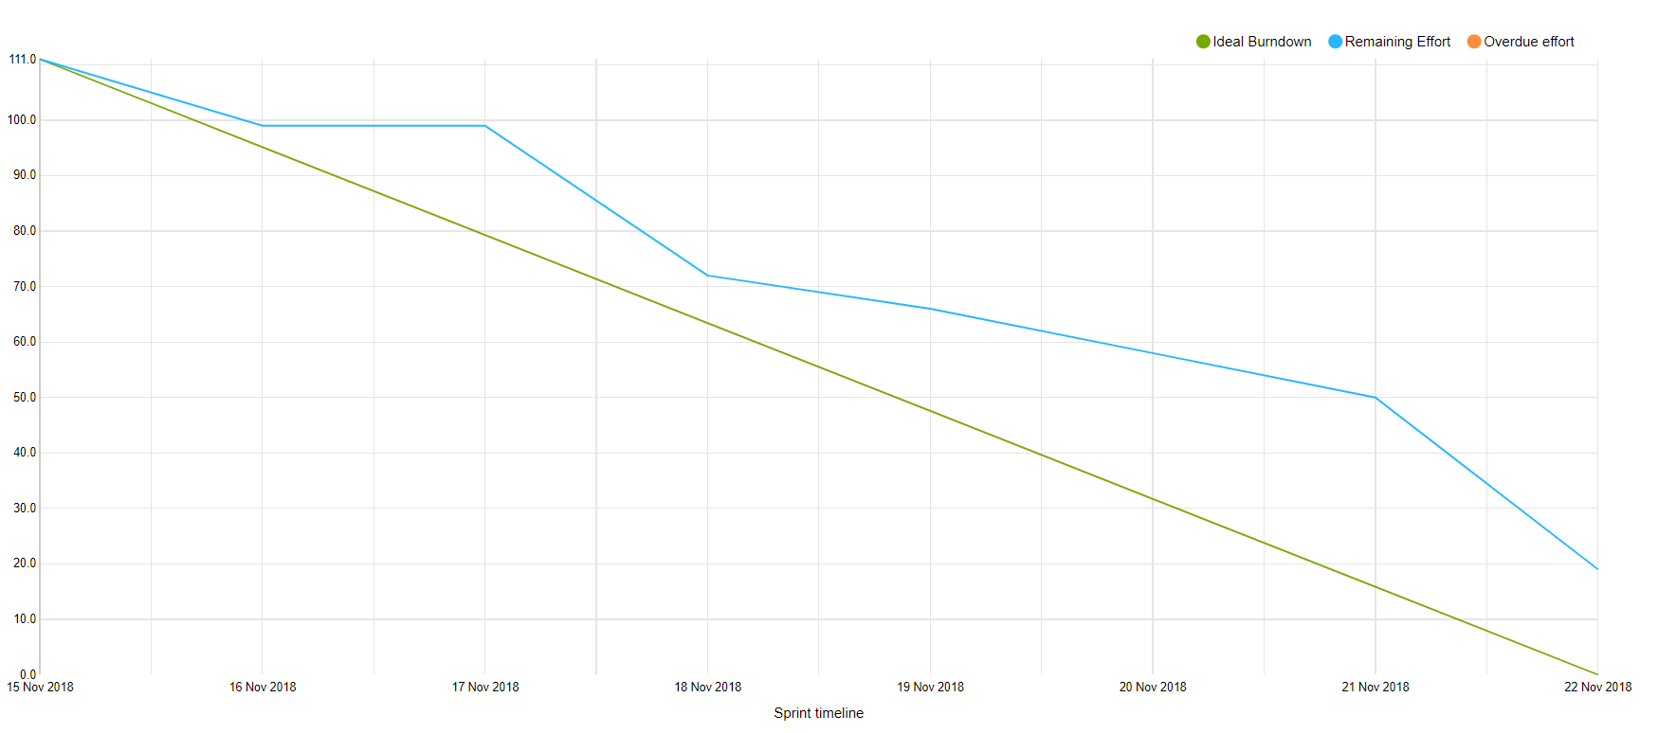

**What is missing:**

* Correct bugs in database
* Redesigned hibernate
* GUI tasks needs connection to API
* The rest of tasks from this sprint are done
* GUI: Registration page

**What is done:**

* Process report
* Class diagram : update
* Database diagram
* Check backlogs and diagrams
* Use case diagram
* Book service : diagram update
* Book service : registration test – controller
* Book service : registration request – POST
* Book service : registration communication with database
* Library : change to new URI
* Database server : registration request
* Database server : users table + hibernate
* Database : test request handling
* GUI: Website : navbar
* GUI: Registration page layout

**Sprint 4:**

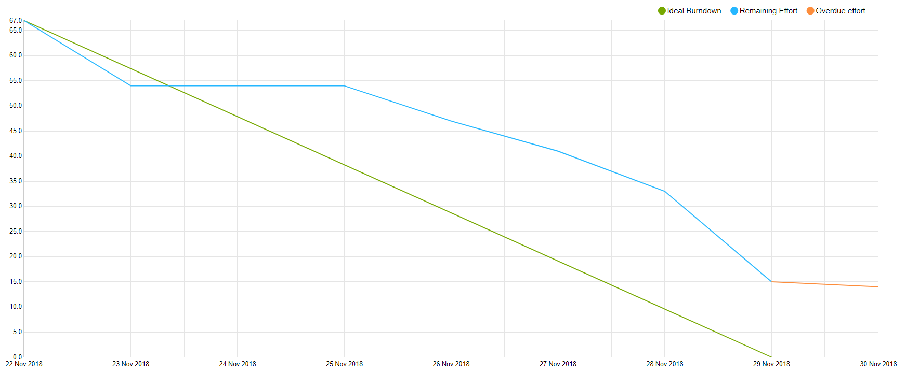

**What is missing:**

* Database documentation in progress
* Website connection of one admin is done second in progress
* Registration page in progress
* The rest of tasks from this sprint are done
* Process report in progress

**What is done:**

* Bugs are fixed
* Use case
* Class diagram : book service update
* Sequence diagram : update
* Documentation of API update
* Documentation of database : update
* Book service : borrow book from the library request
* Book service : buy book from bookstore request
* Hibernate : query builder
* Communication : borrow order / buy order
* Database : add borrow order / buy order
* GUI : update details page with buy and borrow buttons
* Website : advanced search

**Sprint 5:**

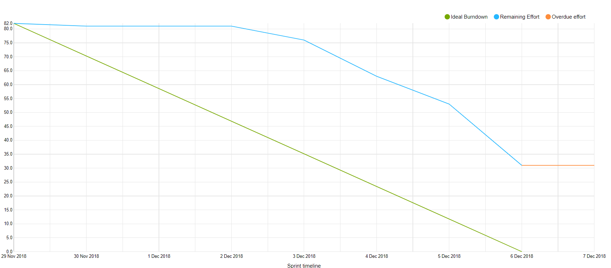

**What is missing:**

*\*First task was figure out how to do login, that’s why tasks started to being done in the half of the sprint*

* Checking session keys is in the progress
* Documentation authentication is in the process
* Login encryption is in progress
* Tests of authentication are in the progress
* Database documentation is in the progress
* Process report is in the progress
* Learning React in the progress

* Website : connect both admins, connect book details list to API, registration page connect to API

**What is done:**

* Use case
* Update diagrams : Book service, Book store, Library, Database
* Documentation of login
* Sequence diagram : login
* Find out how to make login
* All user types are added to database
* Implement authentication
* Implement core of login
* Database and Services : add password

**Sprint 6:**

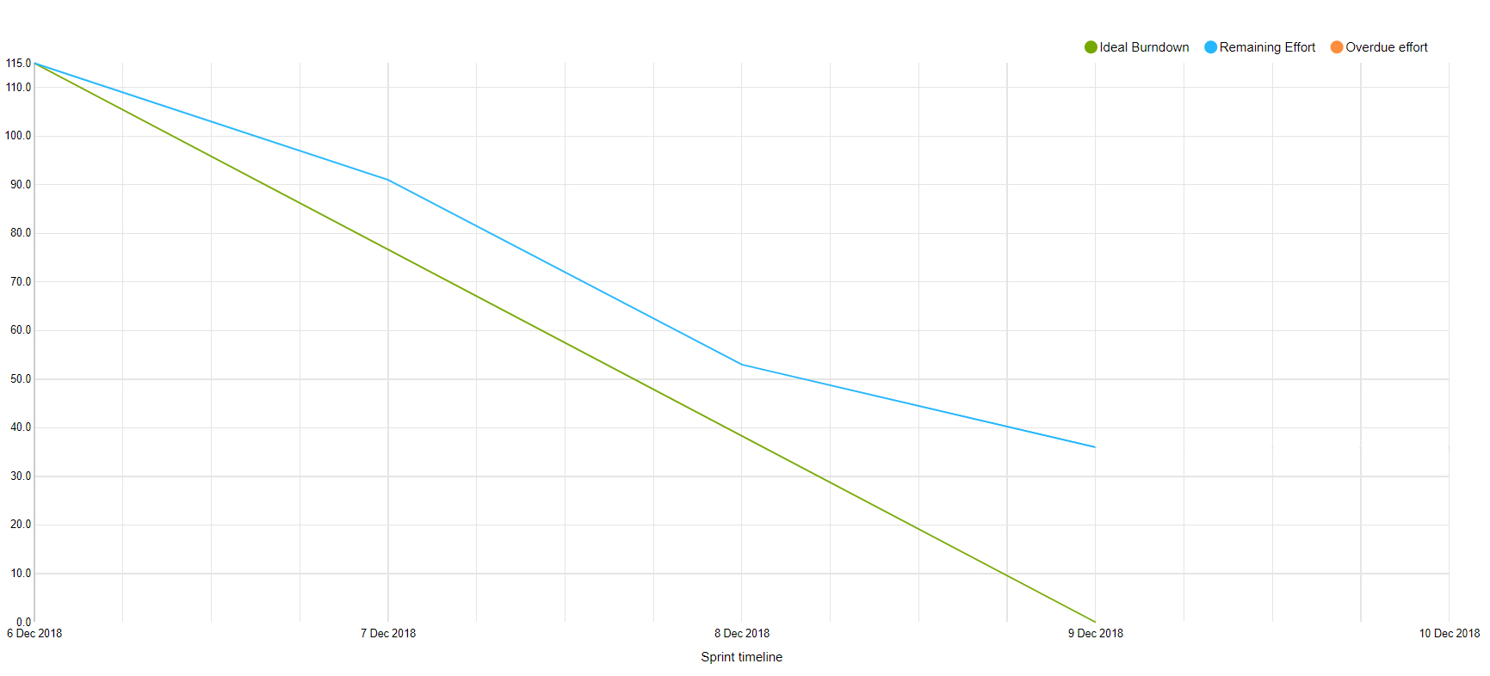

**What is done :**

* Process report
* Database documentation
* Diagrams updated
* Login documentation
* Authentication bookstore document
* Authentication library document
* Use case return book
* Use case confirm book order
* Website login storing cookies, adding cookie in request
* Login encryption
* Book store / Library : confirm order request
* Library : get orders request
* Database handle get orders request
* Database handle order request + communication

**What is missing :**

* Manual tests
* Website : connect both admins
* Website : changing layout after login

**Sprint 7**

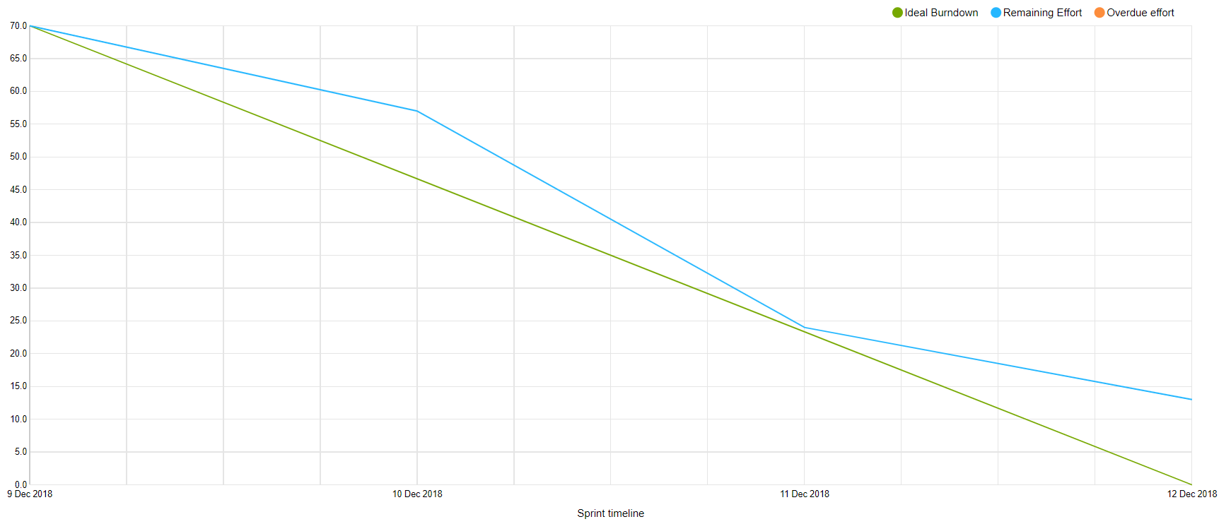

**What is done :**

* Manual tests

* Website : connect both admins
* Website : changing layout after login
* Website : bookstore admin – layout for order
* Website : library admin – layout for order
* Website : library admin – orders connect to API
* Website : connect advanced search to API
* Update webservices documentation
* Update manage books use case
* Security analysis
* Security design
* Database : add URLs to admin
* Database : add customer id to login
* Book service : add checking user type in session key

**What is missing :**

* Website : borrow book connect to API
* Website : buy a book connect to API
* Website : add user ID to post request of borrow and buy in book details
* Correct use case

Sprint 8:

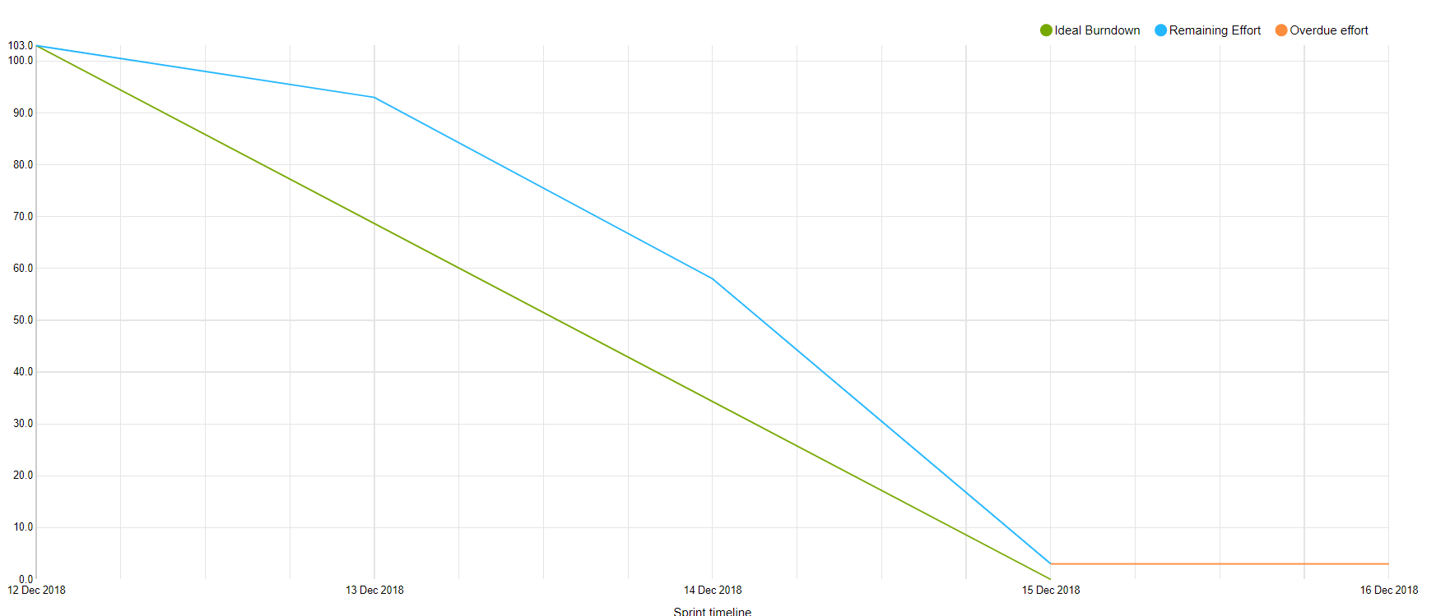

**What is missing:**

* Advanced search bug to fix

**What is done:**

* Correct use cases
* Website : analysis documentation
* Website : design documentation
* Website : implementation documentation
* Project report : analysis, tests, design, implementation, project future
* Books service : logout request
* Bookstore : logout request
* Library : logout request